Running the program from Maven –

Add the below plugin in XML suite that specifies to Maven which XML (suiteXMFile) needs to pick

And run

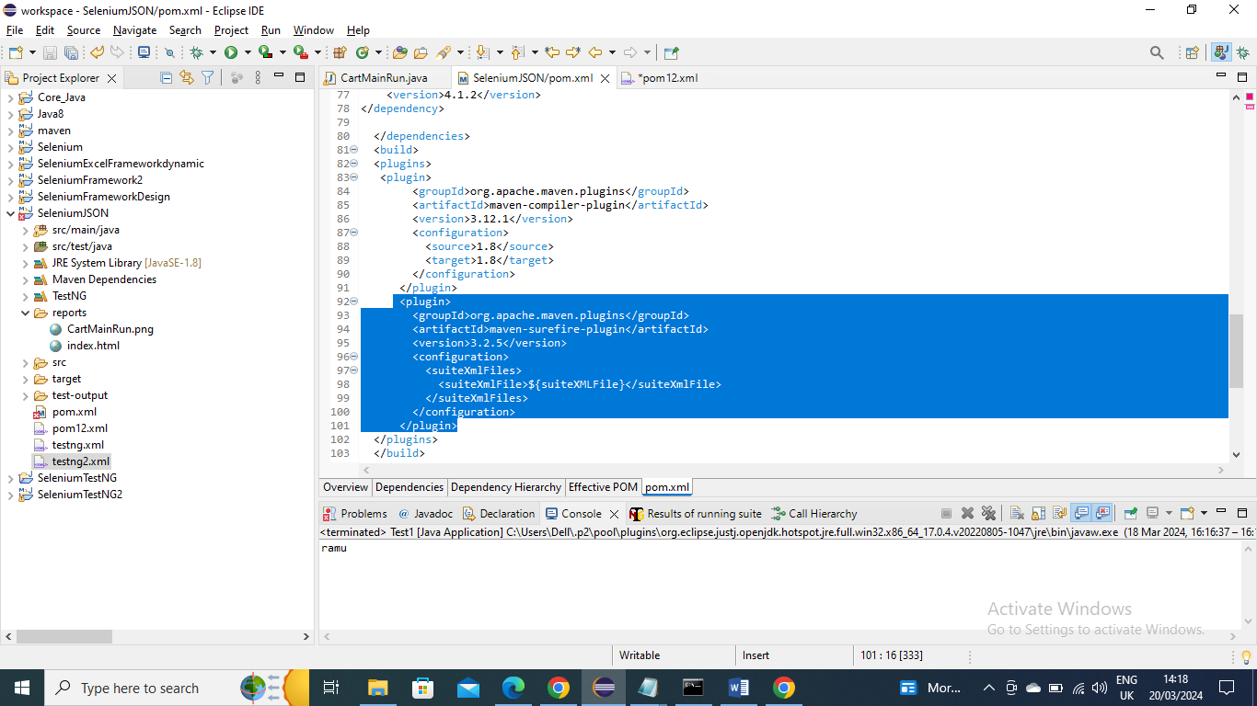

Now run the below maven command

mvn clean test –DsuiteXMLFile =testng2.xml

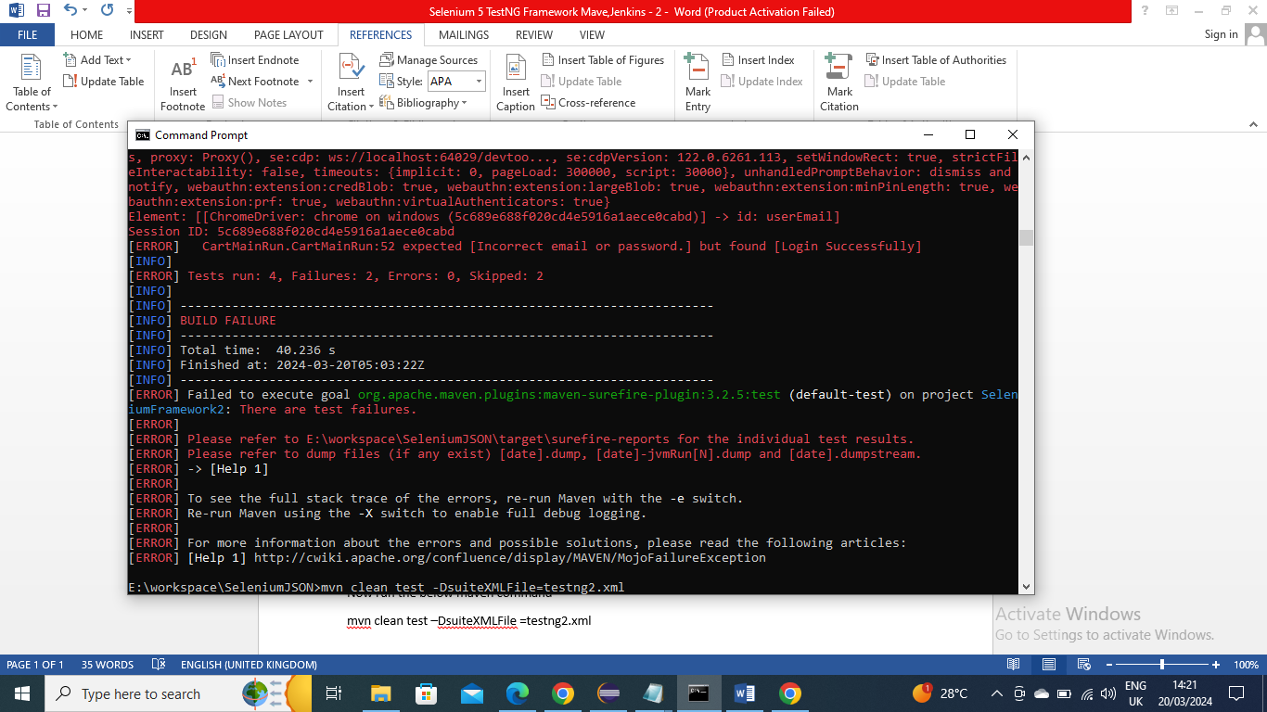

-------------

Now there may be scenario where you want to run only three tests from 100 tests as part of Regression testing or run all Tests for Full testing instead of changing Testng XML file you can have two testing XML files and oint one to regression and other to the Full Test by having them in Profile

Below is the XML

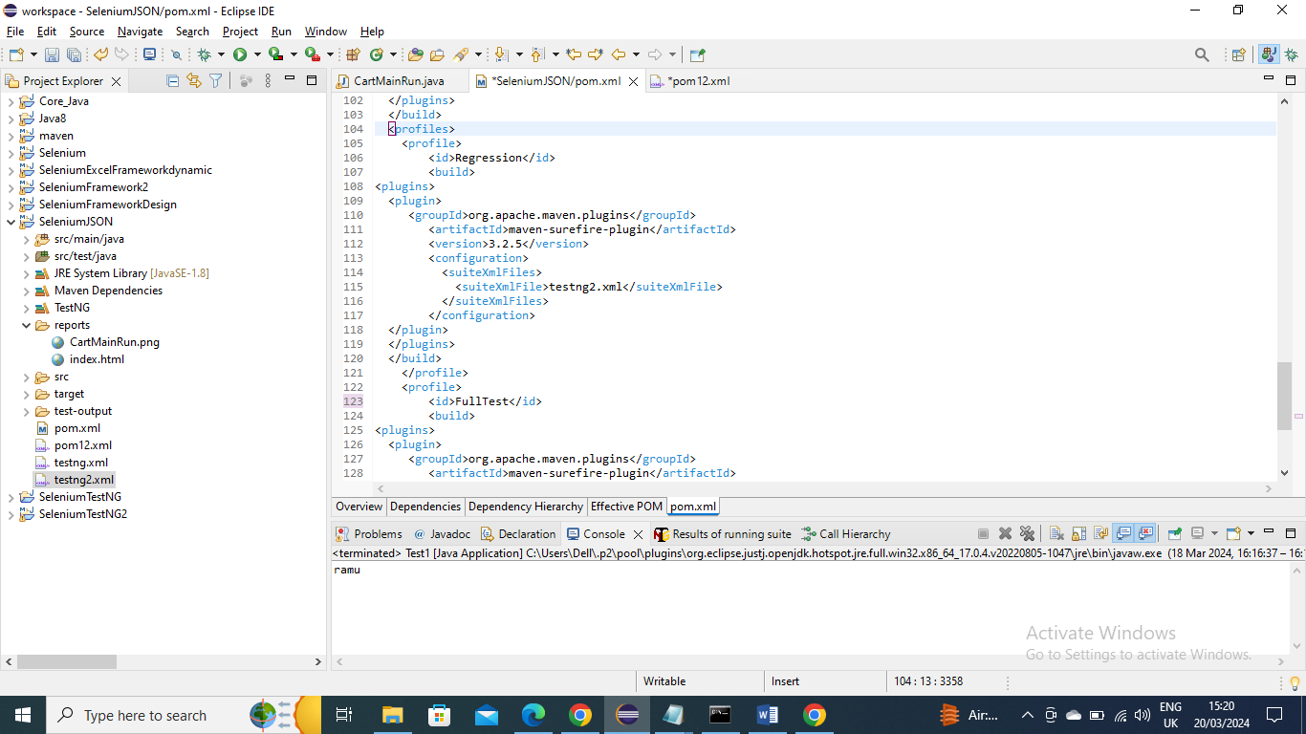

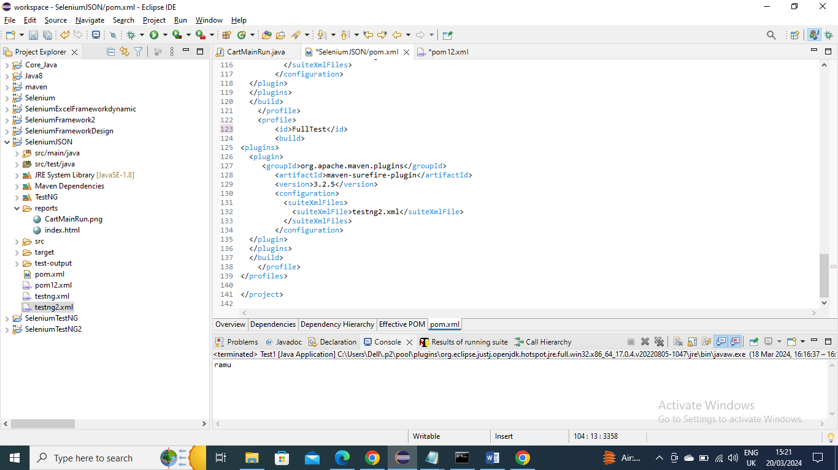

You can run Regression XML by below command

mvn clean test –Pregression

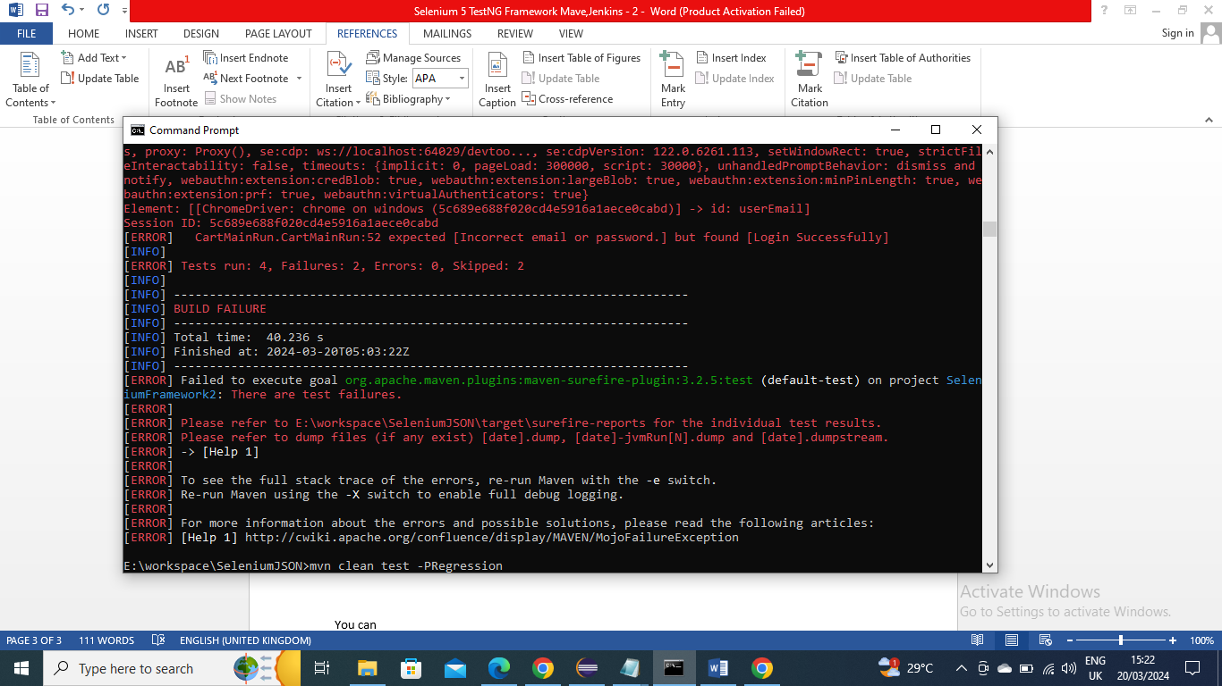

You can FullTest XML by using below command

mvn clean test –PFullTest

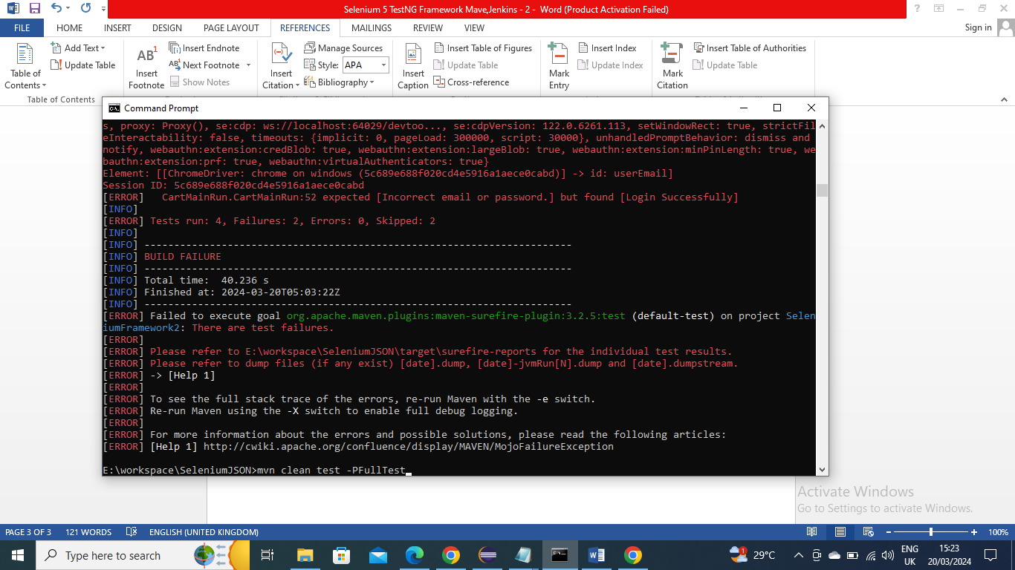

-----------------

Passing parameters from Maven

You can pass parameters from Maven for example say we want to pass from which driver (chrome or firefox or edge…) we want to run…..You can pass the parameter from maven

In below program we mentioned that check if parameter is sent from maven if Yes then pick it from maven otherwise pick the driver info from properties file

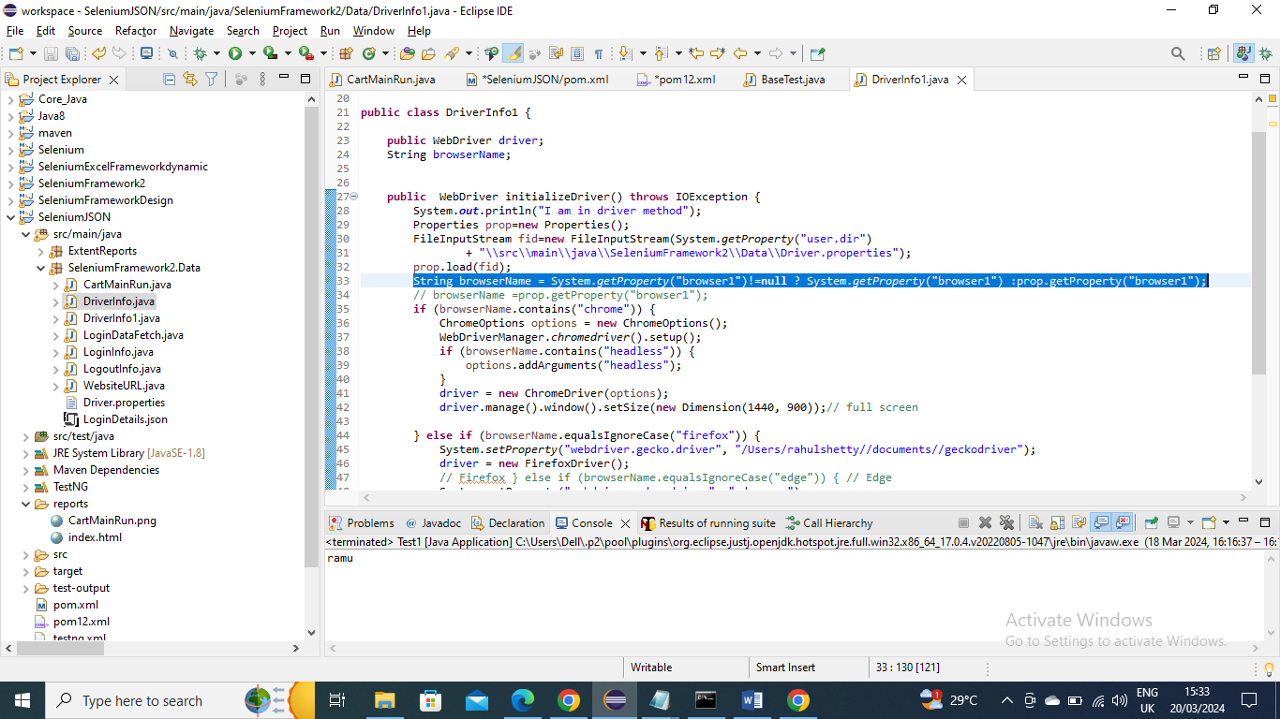

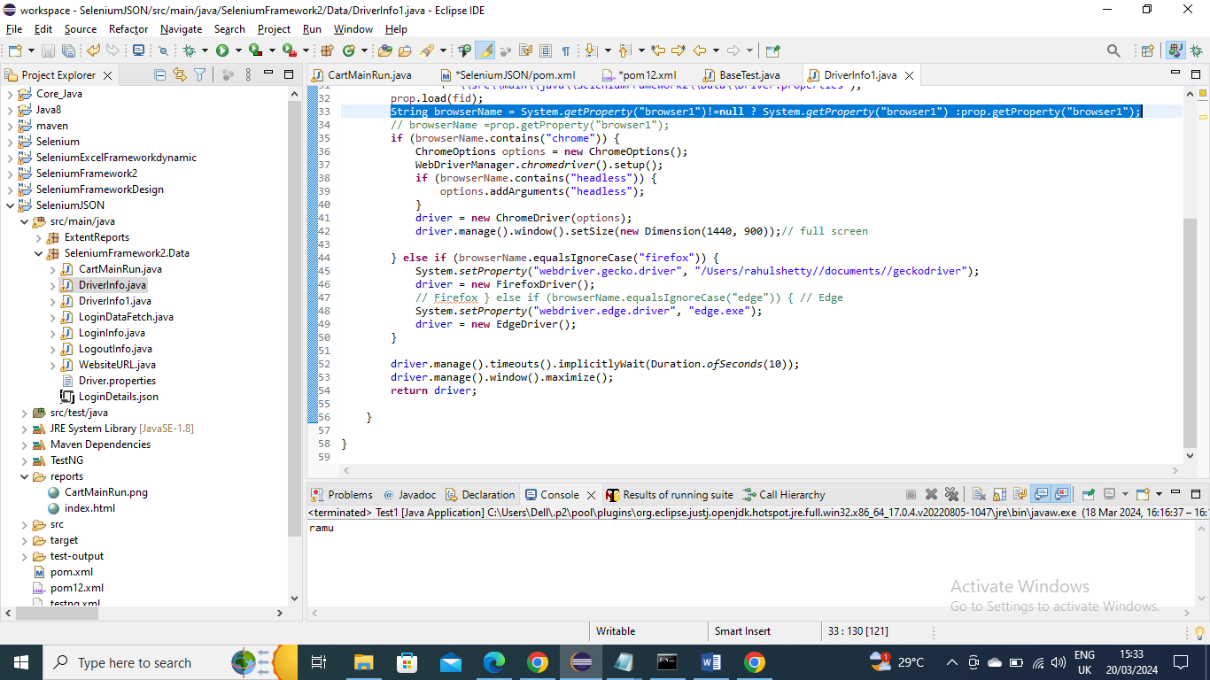

Now below is the way we pass the parameter

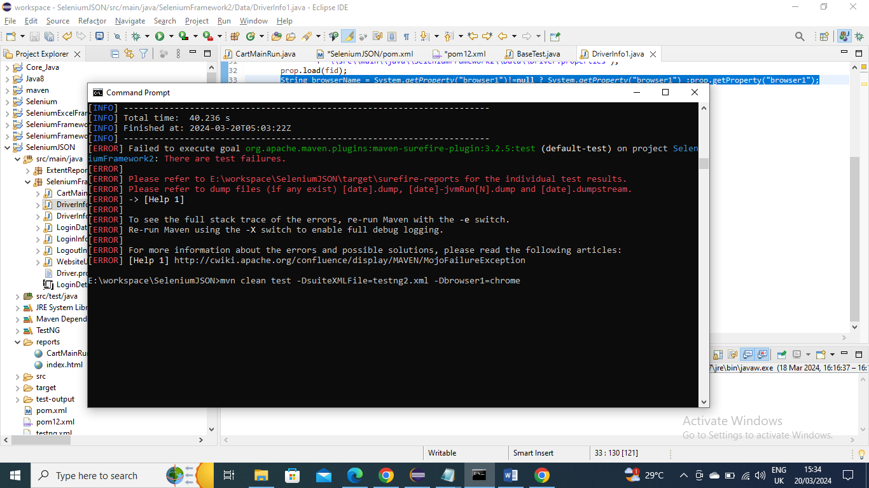

----------------

Jenkins -

Click on “New Item” to create a new Job

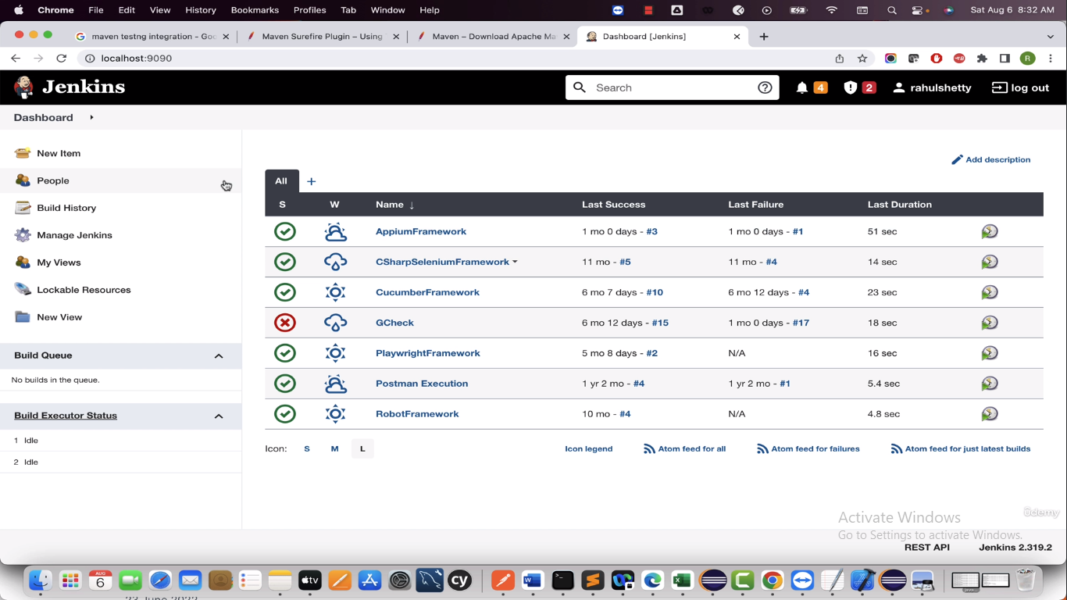

Let’s say “Selenium Framework” and select Freestyle project and click on OK

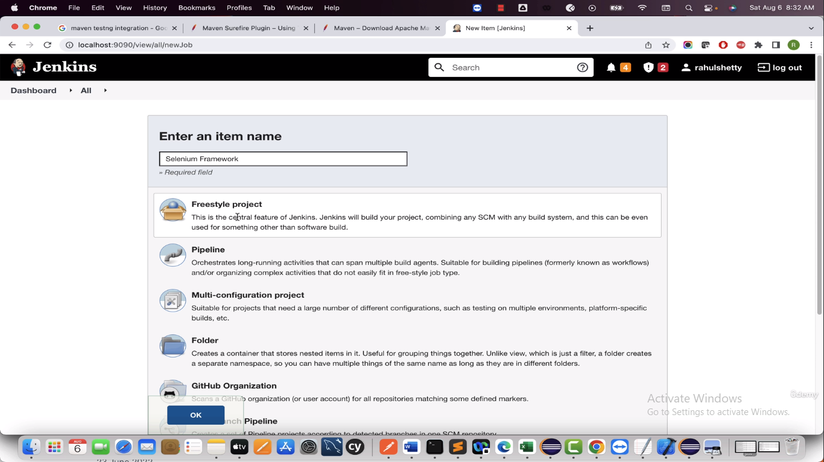

If you have code if GIT then provide the GIT URL

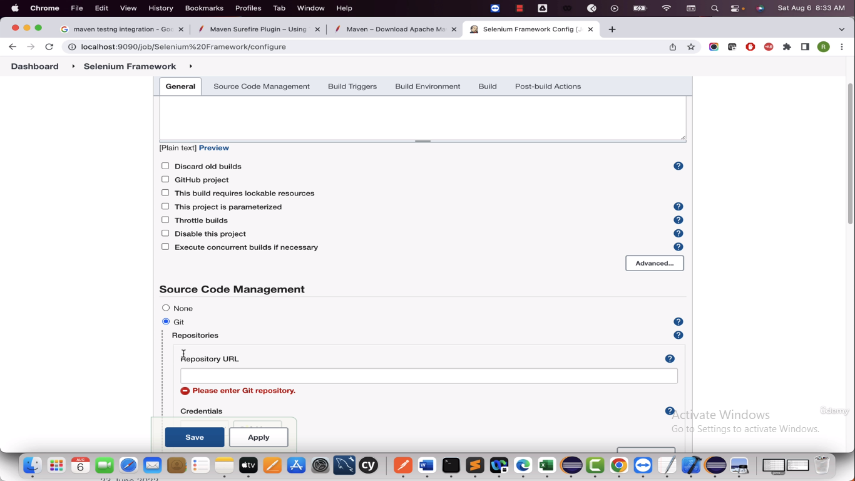

Since we have code in our local system Click on Advanced below and select “Use custom workspace”

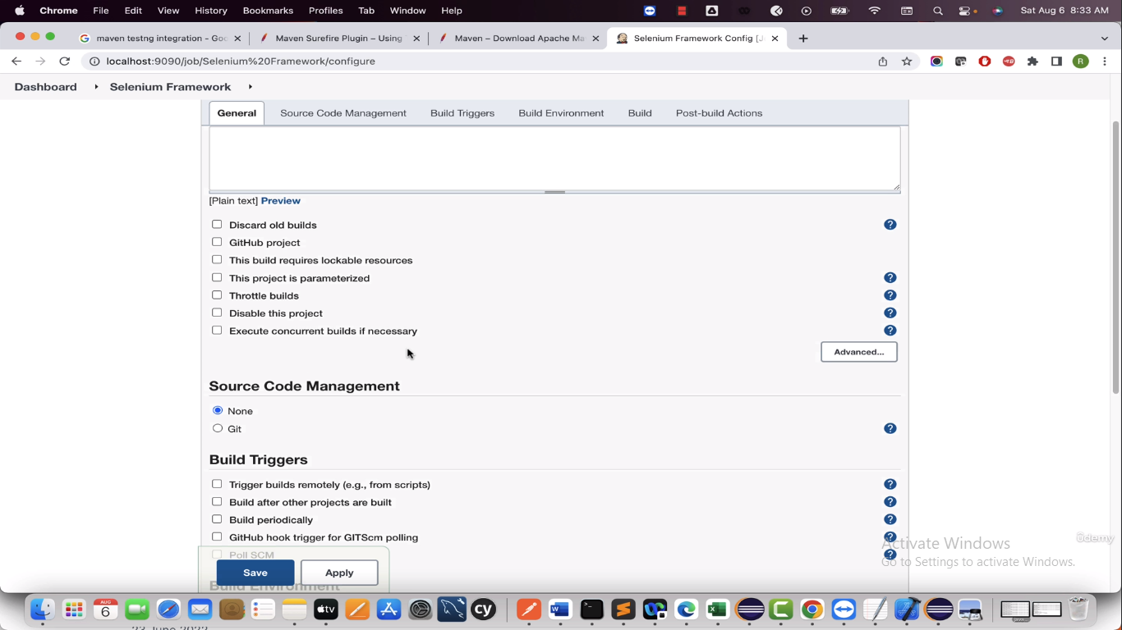

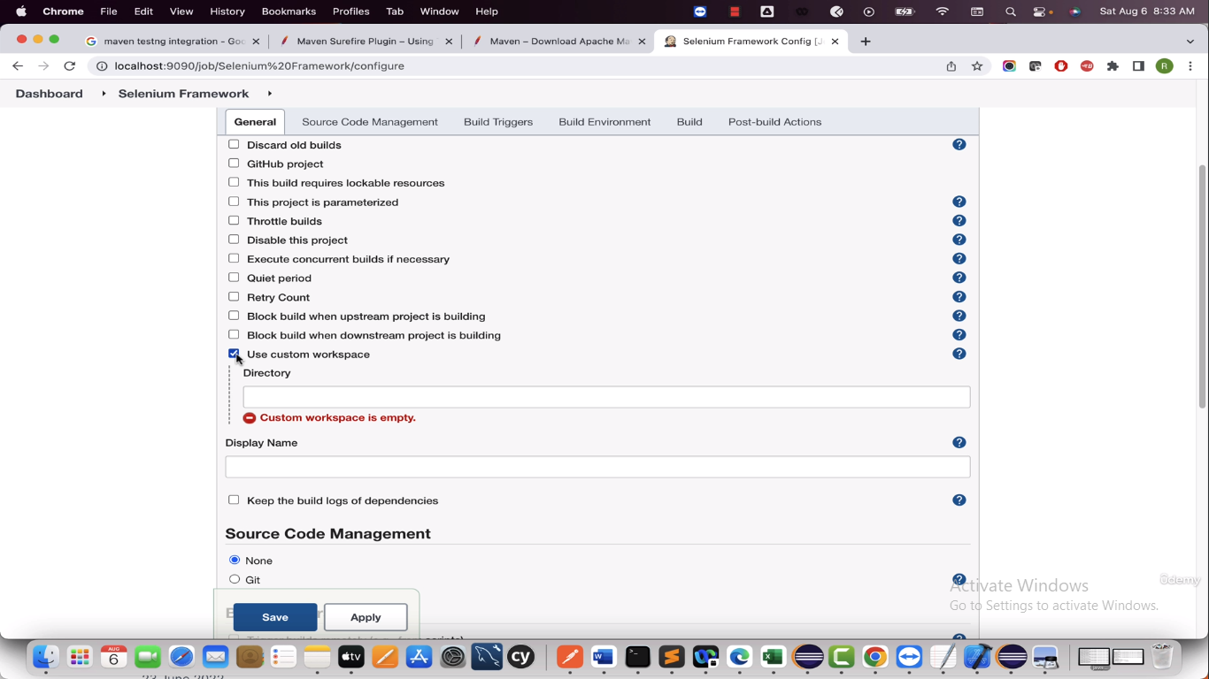

Now give the Project path

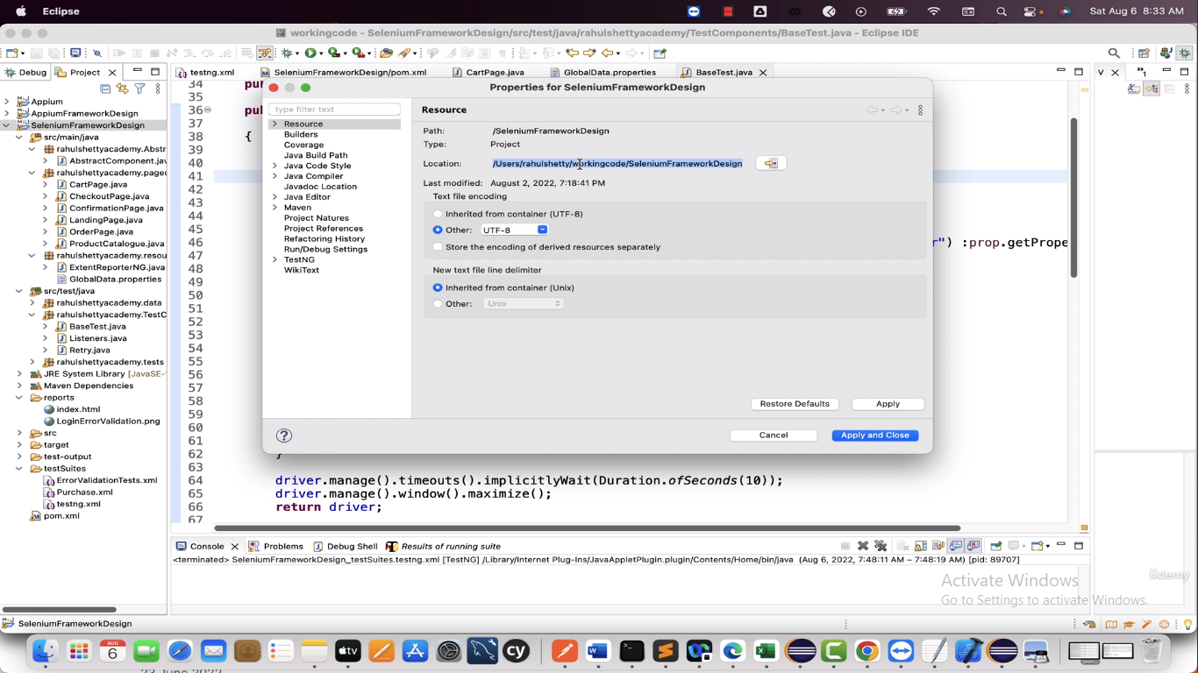

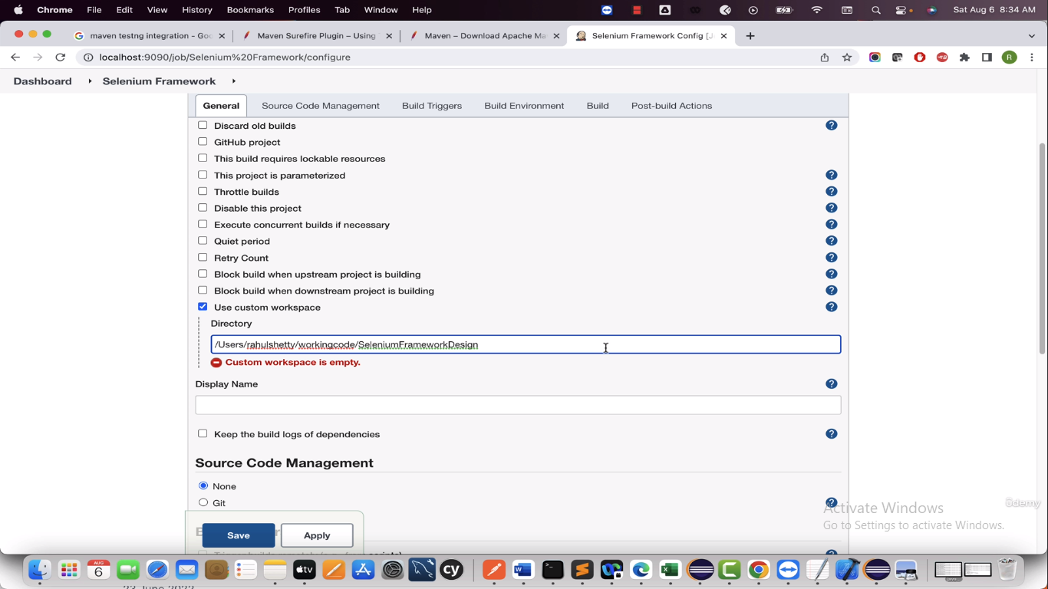

Now we will Build the project to run the tests. Since we run on Maven dependencies select “Add build step” and select “Invoke top-level Maven targets”

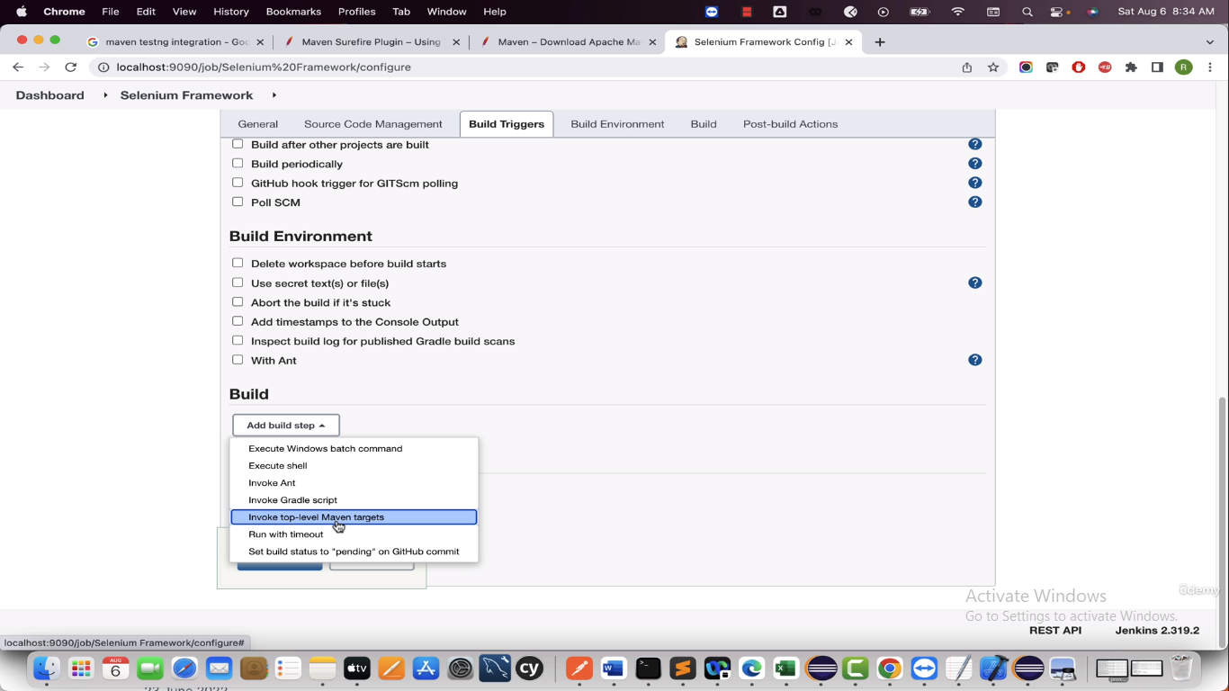

Now provide the maven command that is used to run the project

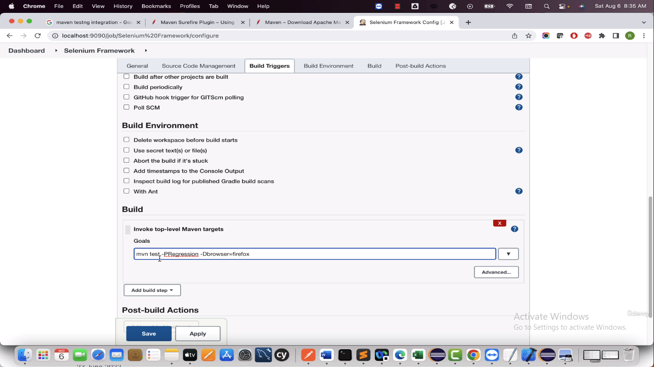

Here mvn is not required since Jenkins will add it

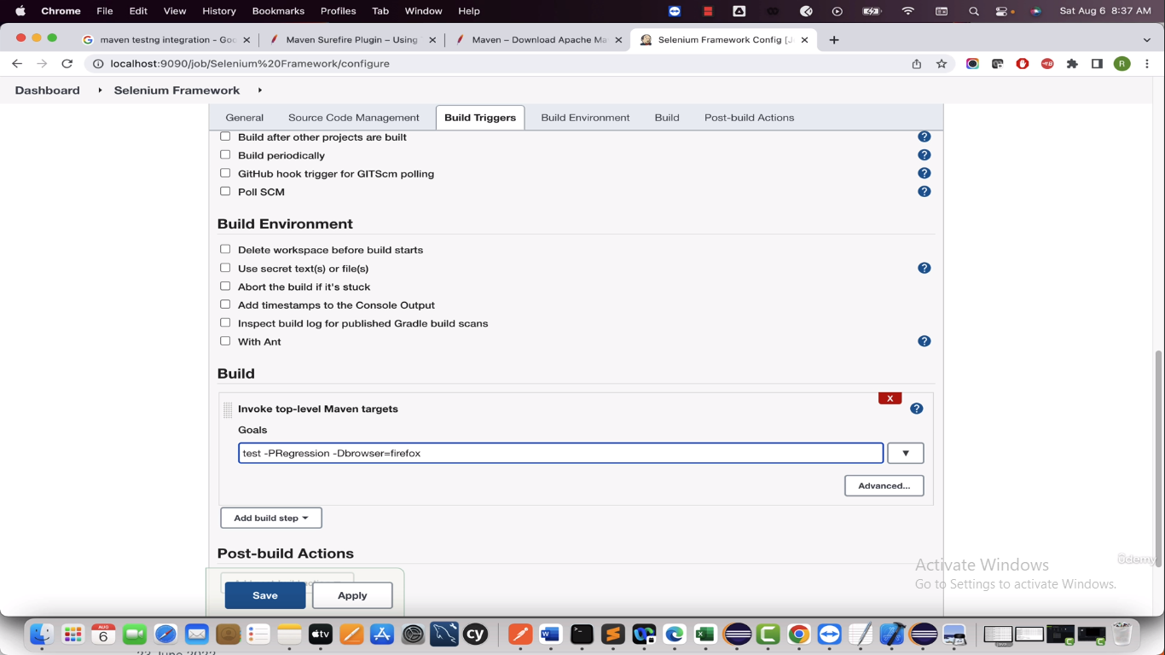

Now save it

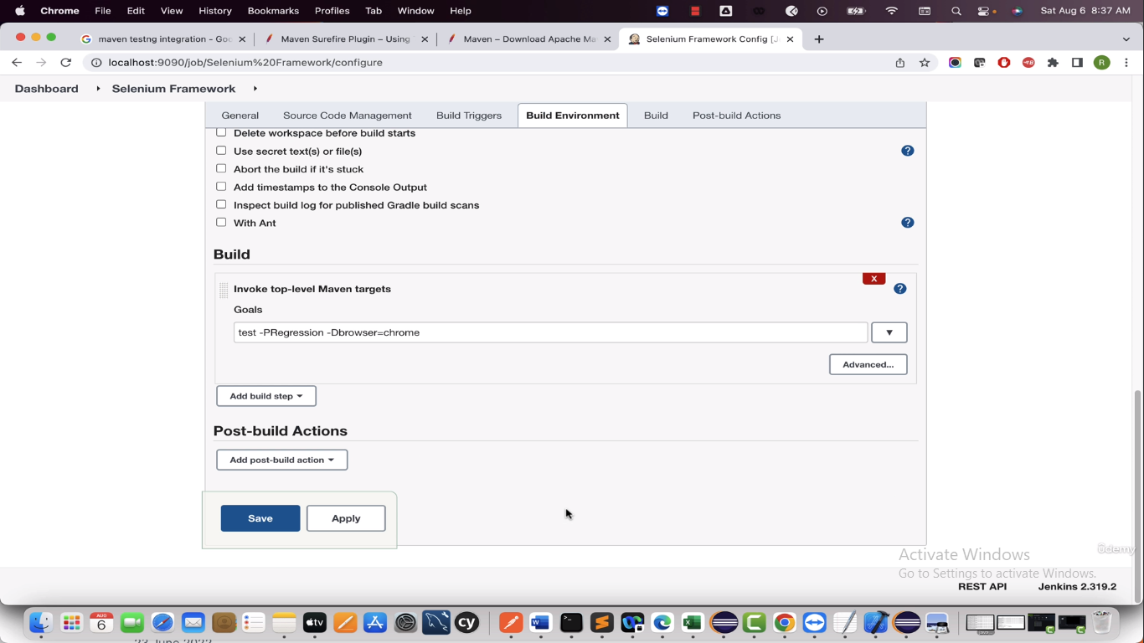

Now let’s run the project select ”Build now” it will run the project

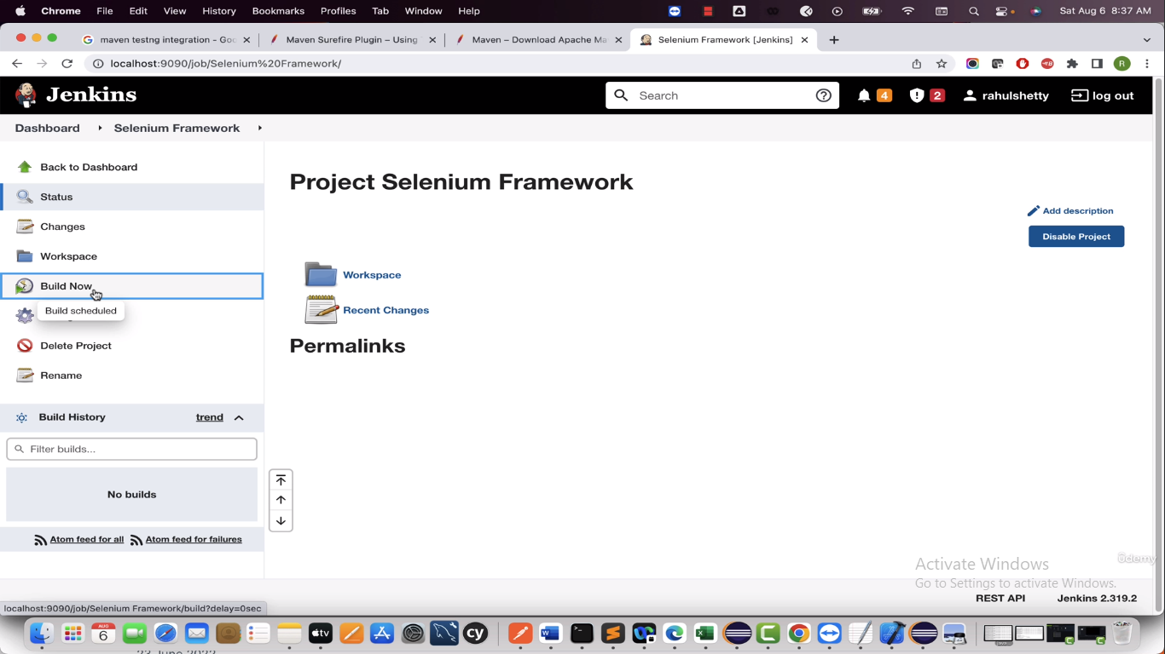

To check the logs you can go to that job and go to “Console Output” and here you can see the logs

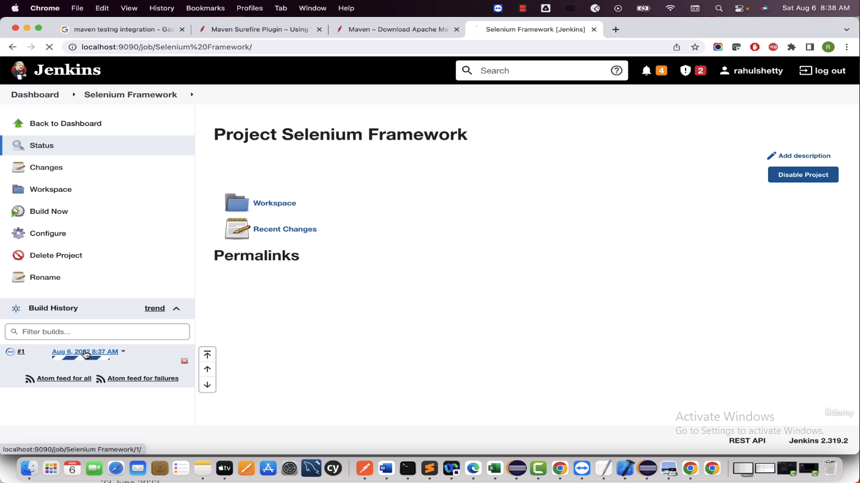

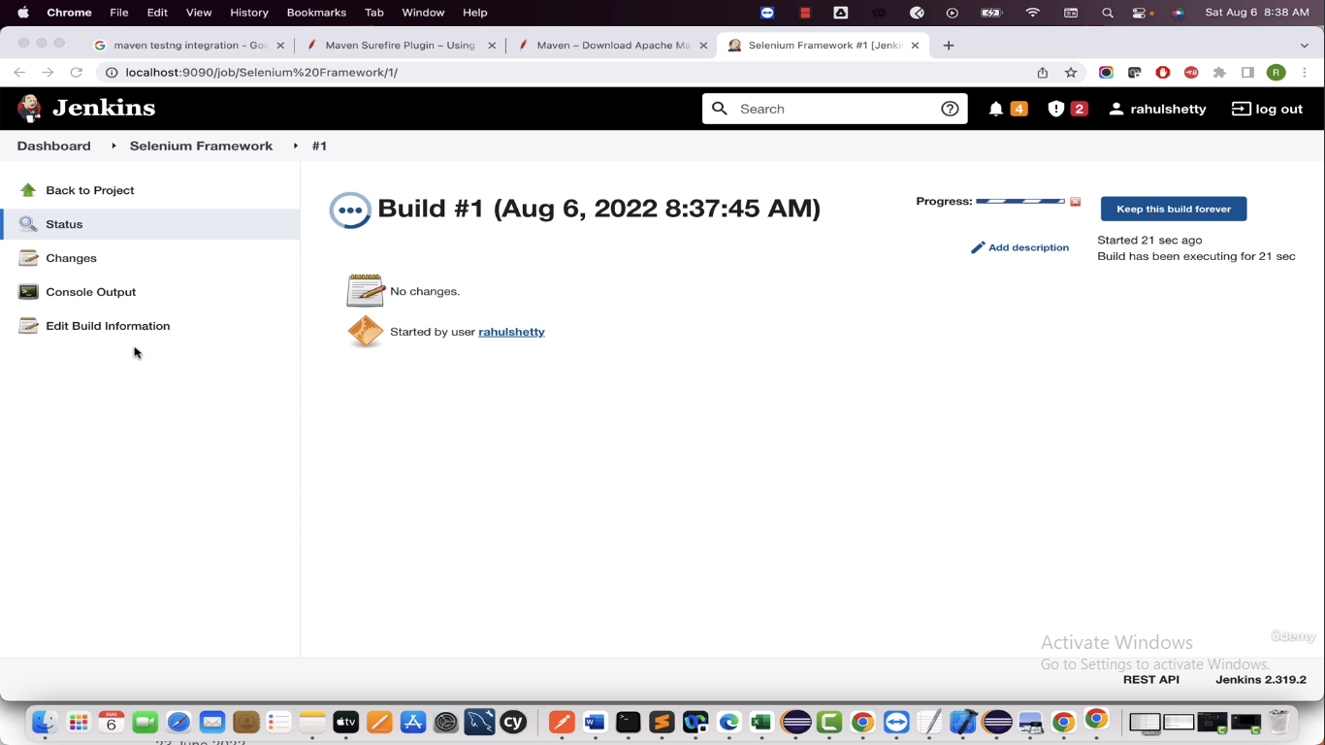

All good and test ran

-----------------------------

Now in above we are hard coding the browser name, if someone wants to run project in firefox then they have to change so it kind of someone needs to change.

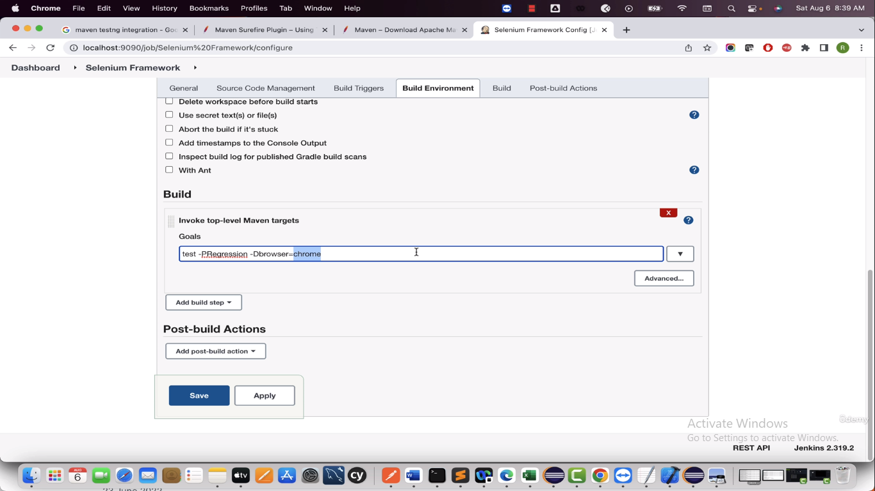

To change it dynamic we paramterise it

Got configuration

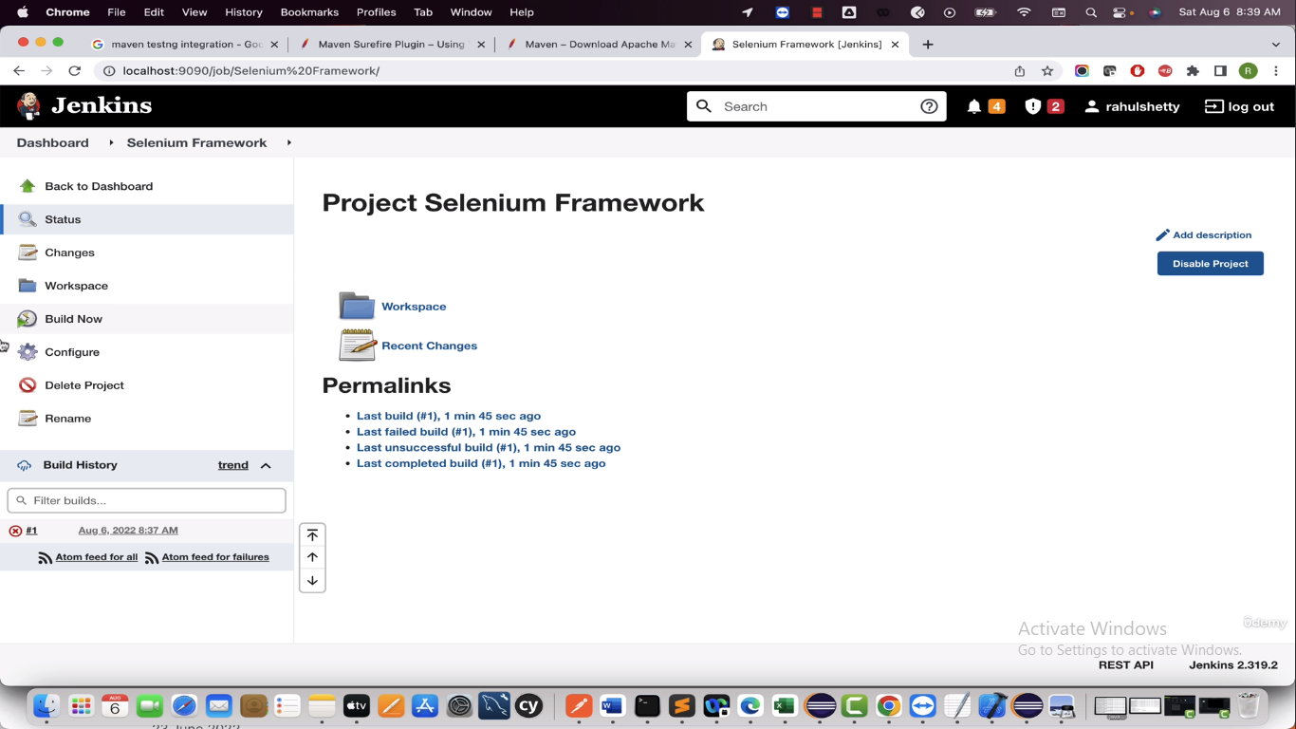

Select the checkbox “This project is parameterised” and select “Choice Paramter”

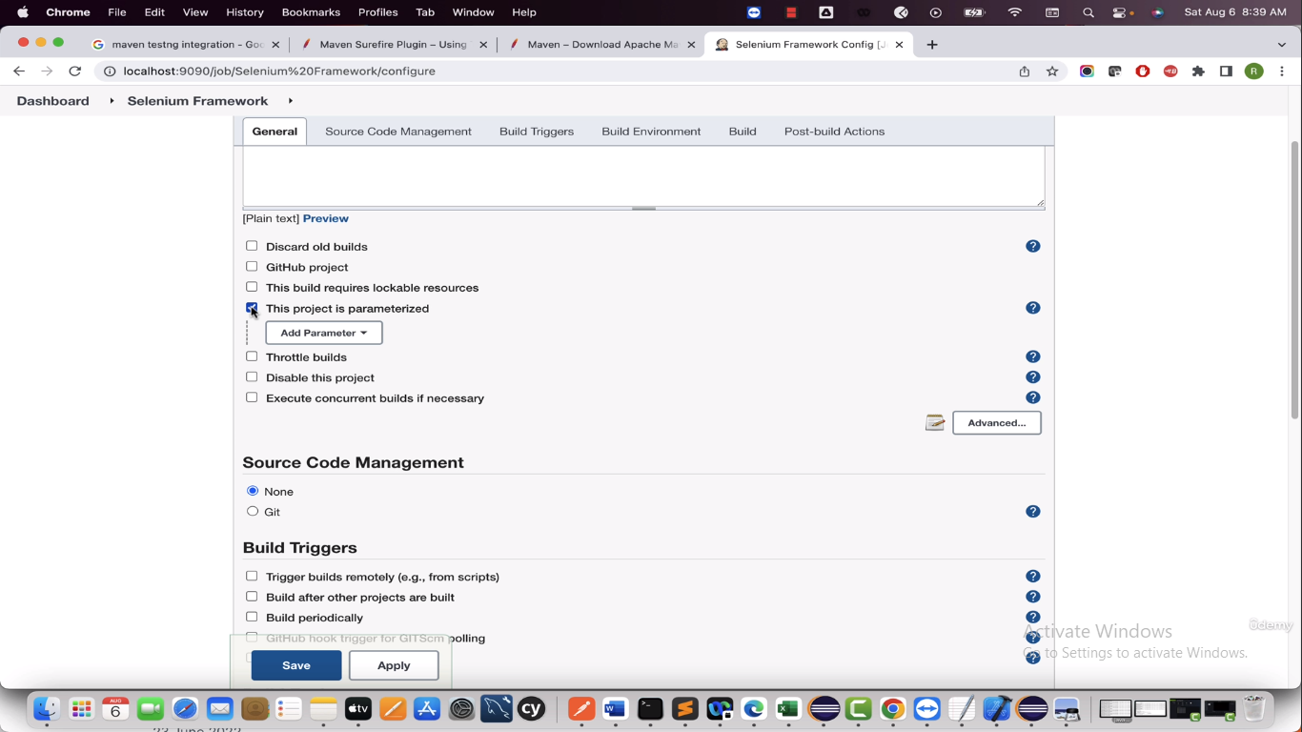

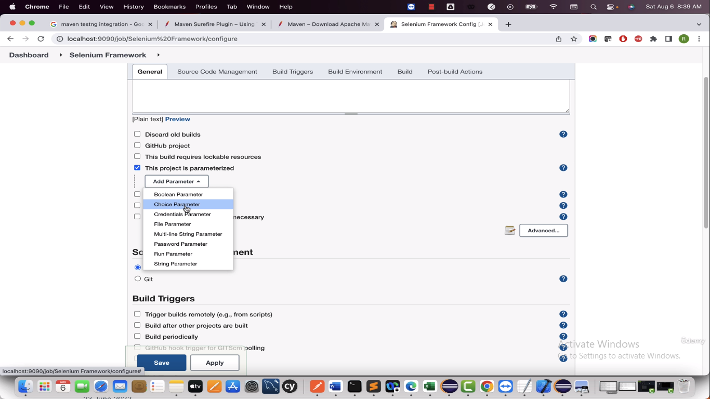

Now provide the parameters for browser and click on save

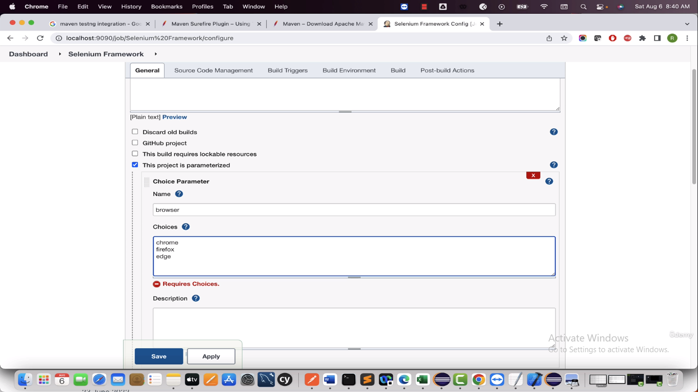

Now it automatically change Build to Build with parameters

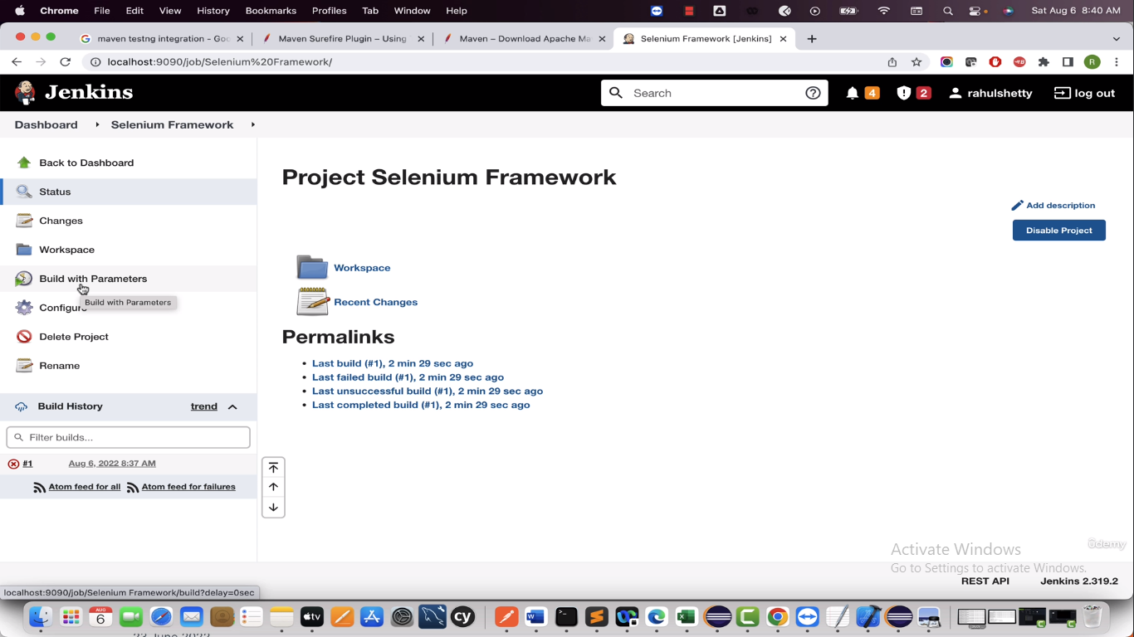

Select the Build with parameters and here you can select which browser you want to run

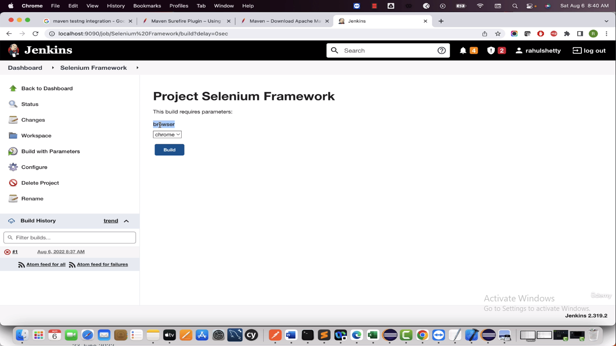

Now we need to handle that dropdown so we need to change maven command to below so that the dropdown value is passed to below

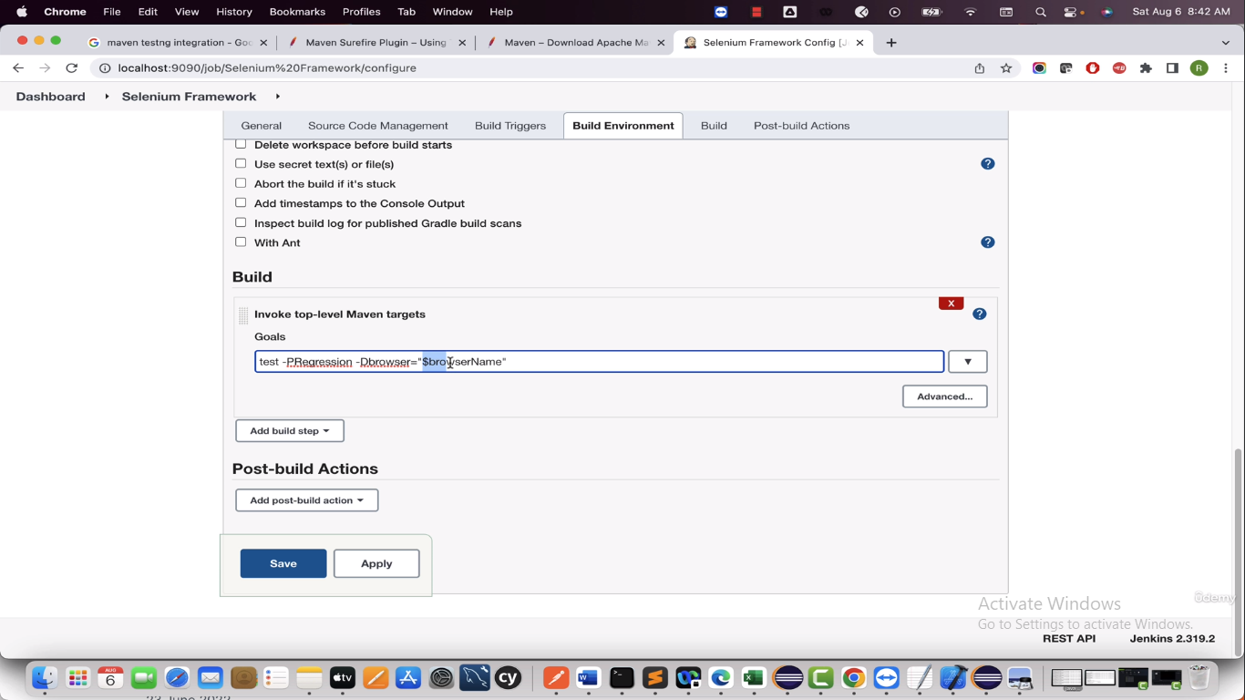

Now go to Build with parameters and select any browser from dropdown and click Build to run the project





---------------

Now in below Regression(profile) is hard coded we will make it dynamic as well

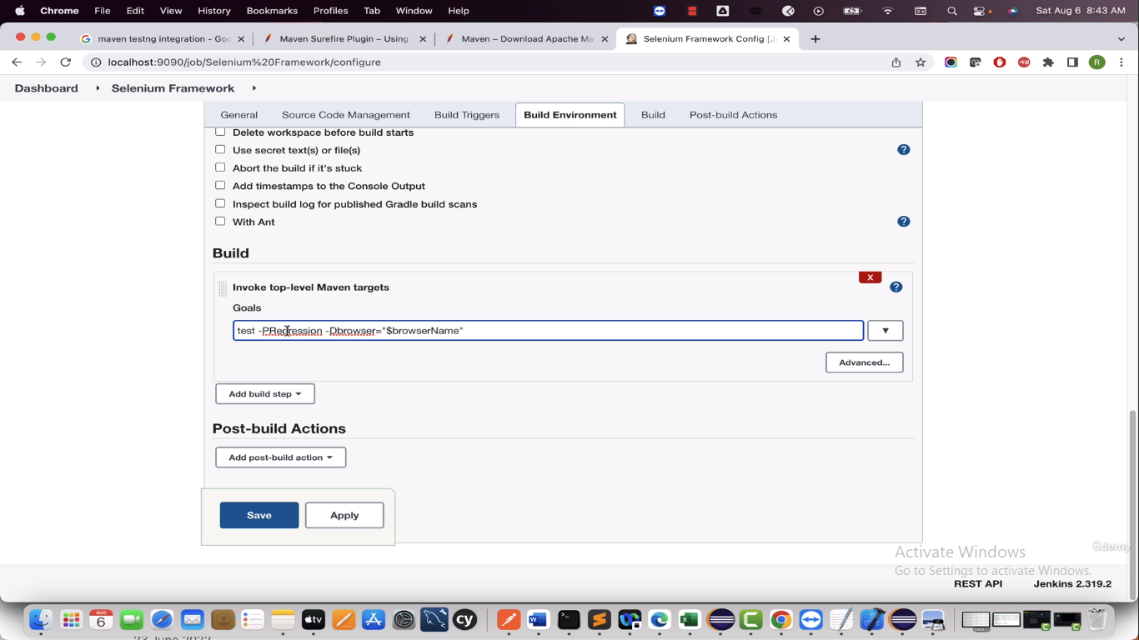

Click on Add parameter and select choice parameter

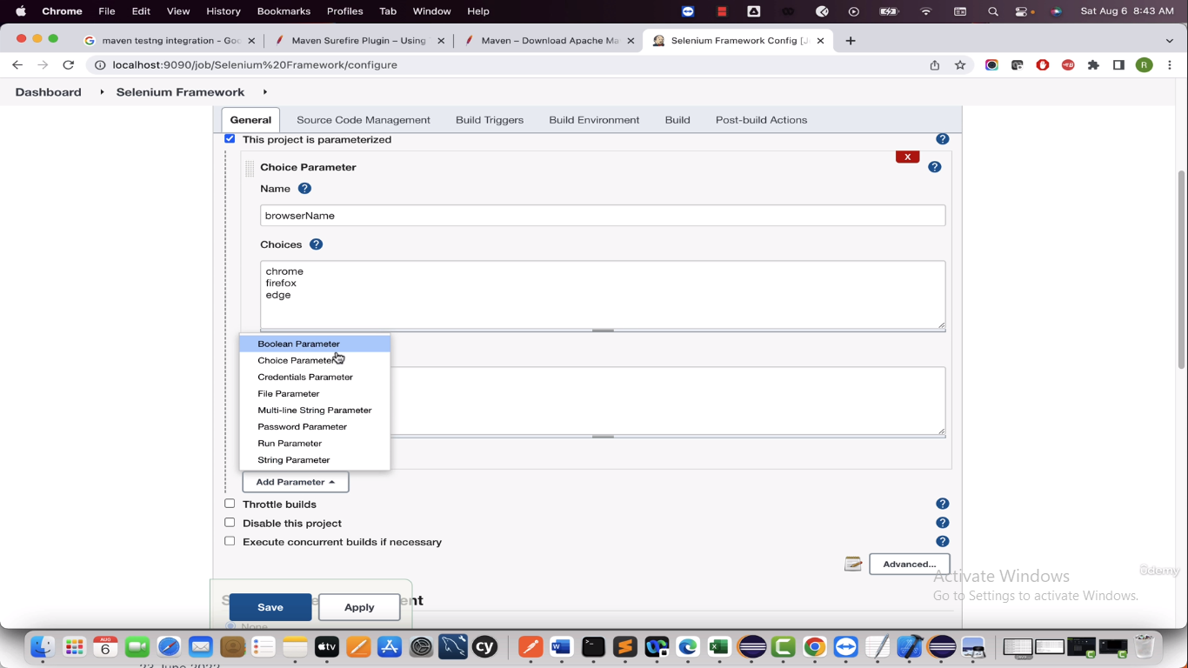

Give the details of Profiles

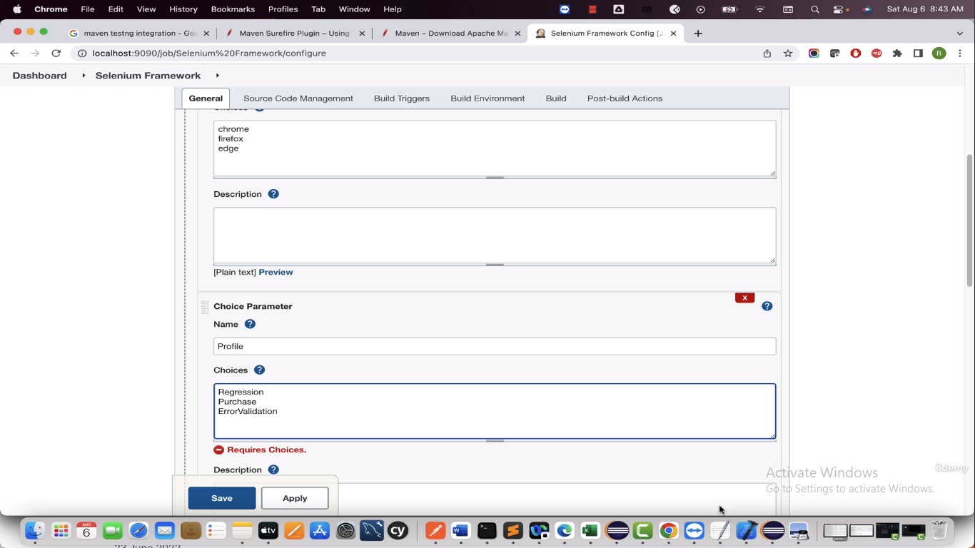

Now change the maven command to handle the profile and save it

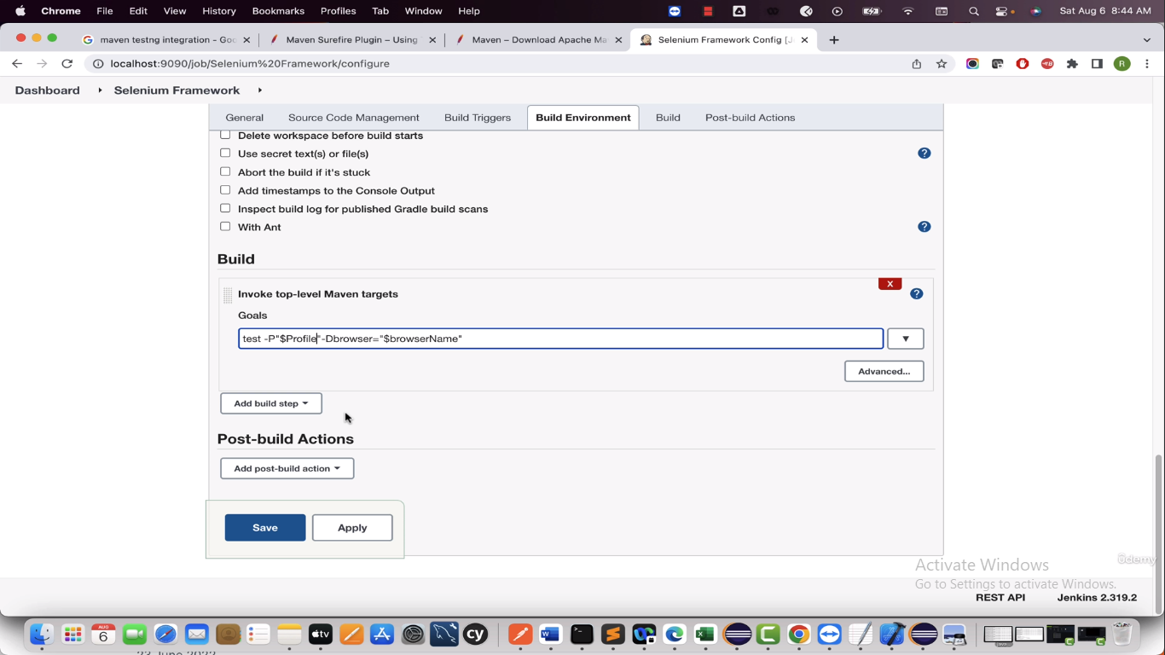

Go to Build with parameters and select the dropdown for browser and Profile and click on Build to run the project

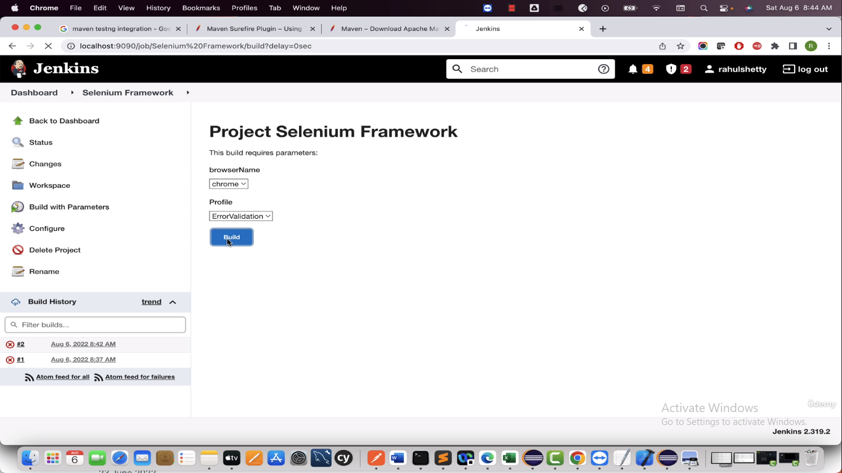

--------------

Headless – means when you run the project it runs at background

If you want to run the project headless then make necessary changes to handle in java code

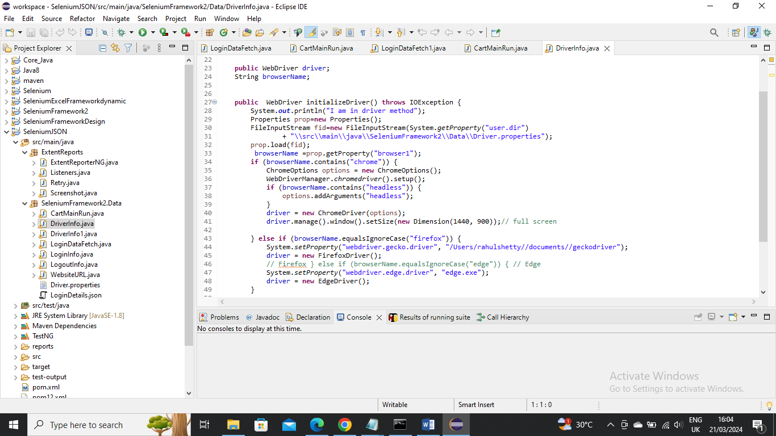

Add the choice parameter chromheadless and save it and then click on Build with parameters and select chromeheadless and profile parameter and click on Build to run the project

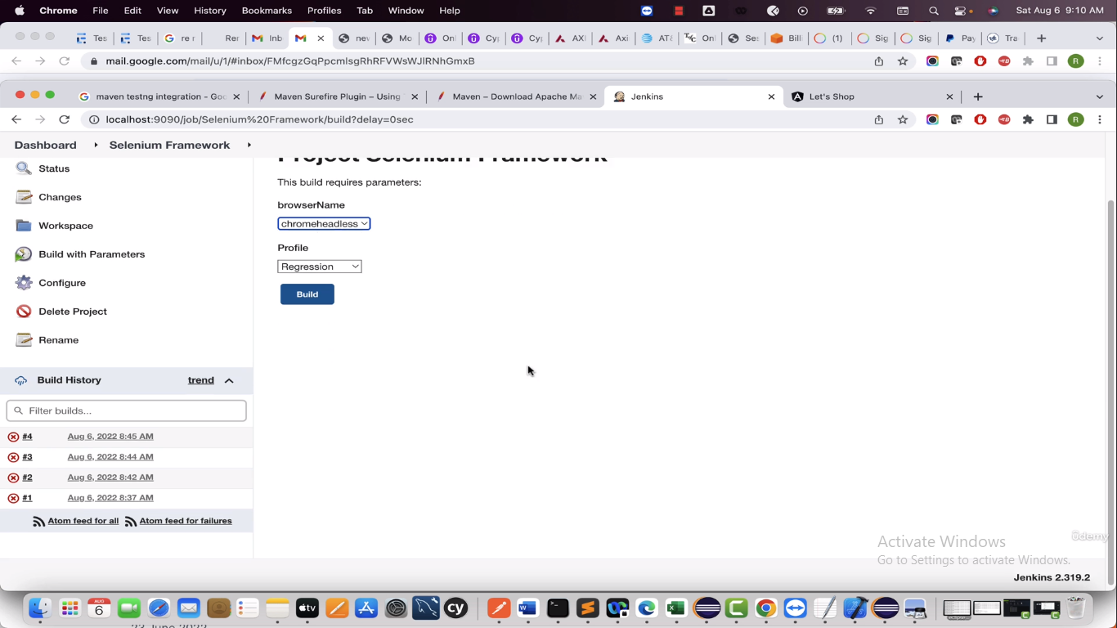

---------------

If we want to schedule the Job to run at specific time

Got to configure

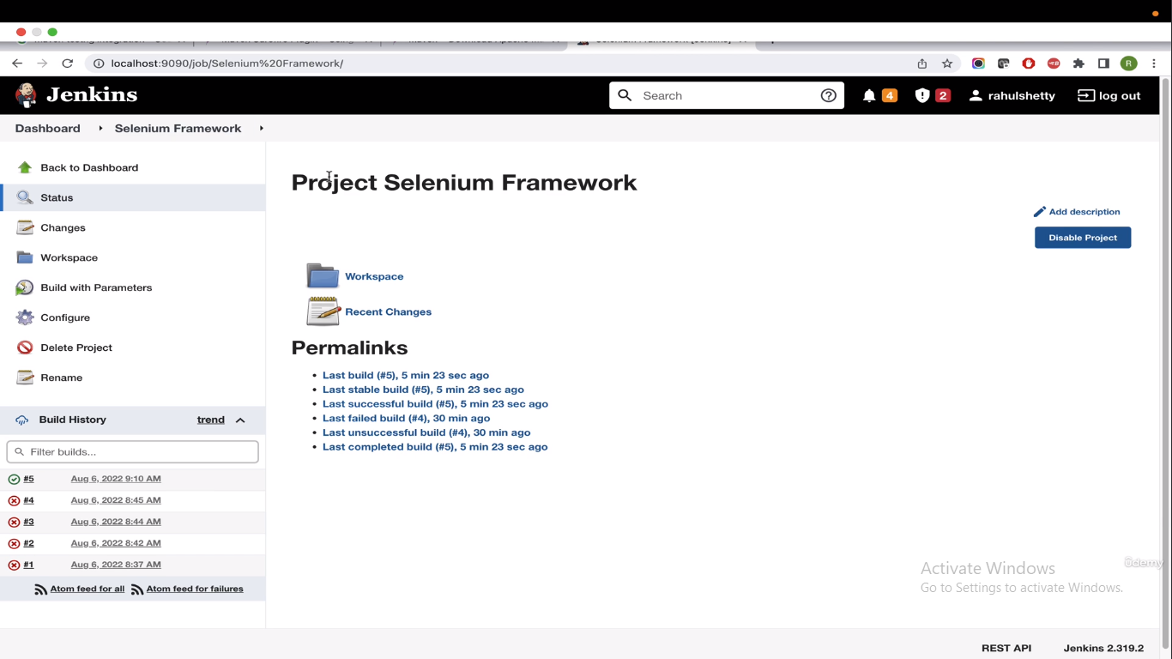

Select “Build Triggers” tab

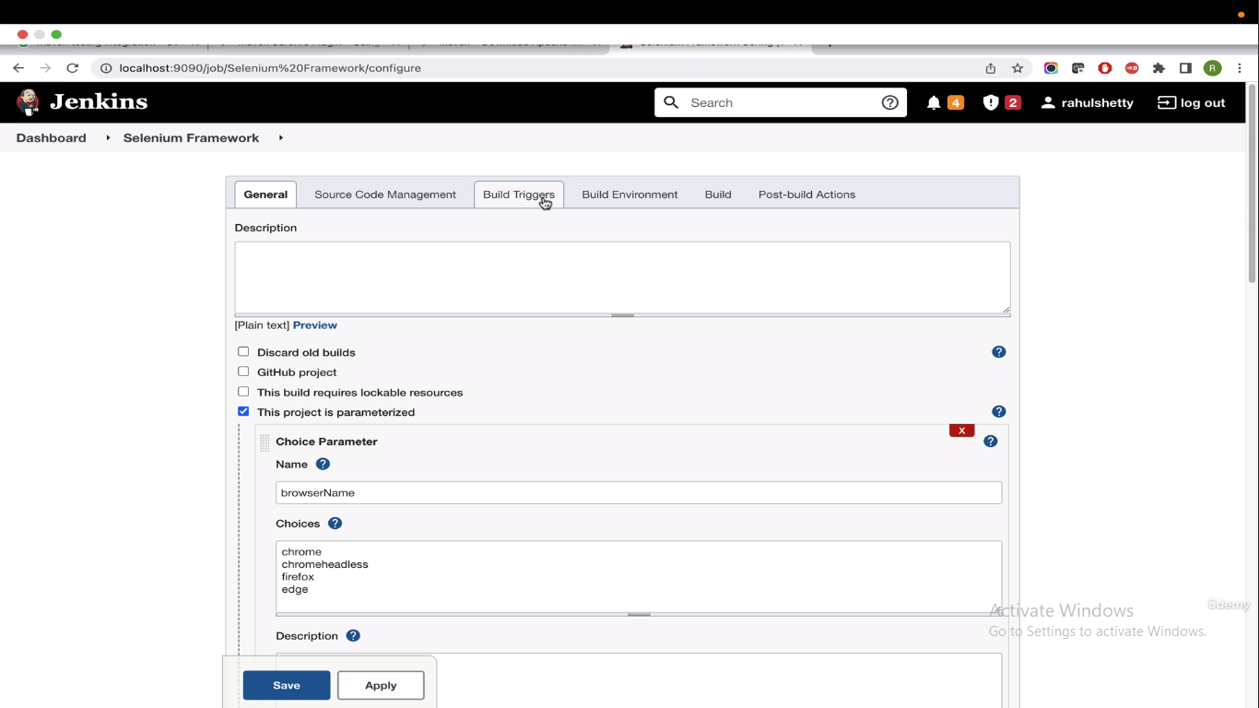

Now select “Build periodically”

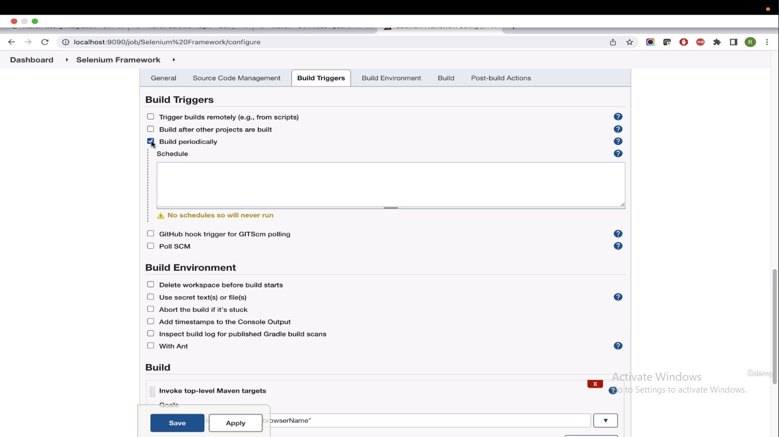

Below is format you can needs to be entered in schedule

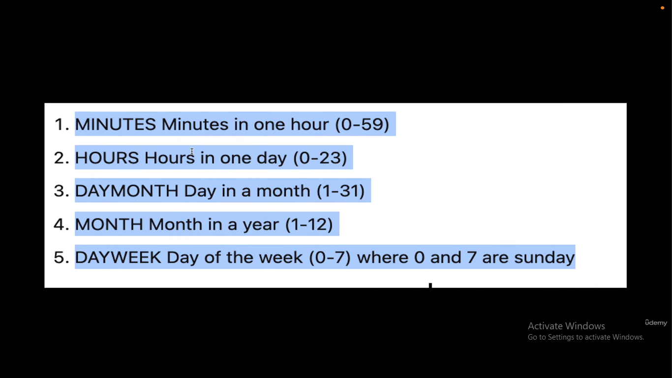

Example : 2 6 10 11 \* -----this will run on every 10th of Novemeber at 6:02 AM

Example: \* 6 \* 12 0 – here it runs on December on Sundays at 6 AM

Here \* means all days

Below is scheduler we update and save it

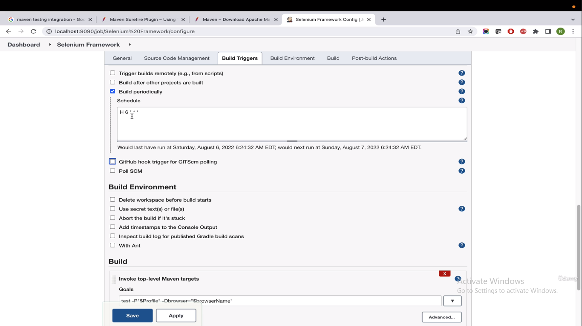

Please note we didn’t give \* 6 \* \* \* because what happens is the Jenkins will think it should runs at 6:00 to 6:01 all 60 seconds so it will create 60 different runs so we have specified as H so that it runs only once

Now the job runs at 6 AM

----------------------------